**Step 1: Setup Git Repository**

**Description:**  
Created a new folder git-branch-lab and initialized it as a Git repository with an initial commit.

**Commands Used:**

git --version

mkdir git-branch-lab

cd git-branch-lab

git init

echo "Initial commit" > readme.txt

git add readme.txt

git commit -m "Initial commit on master"

**Screenshot(s):**  
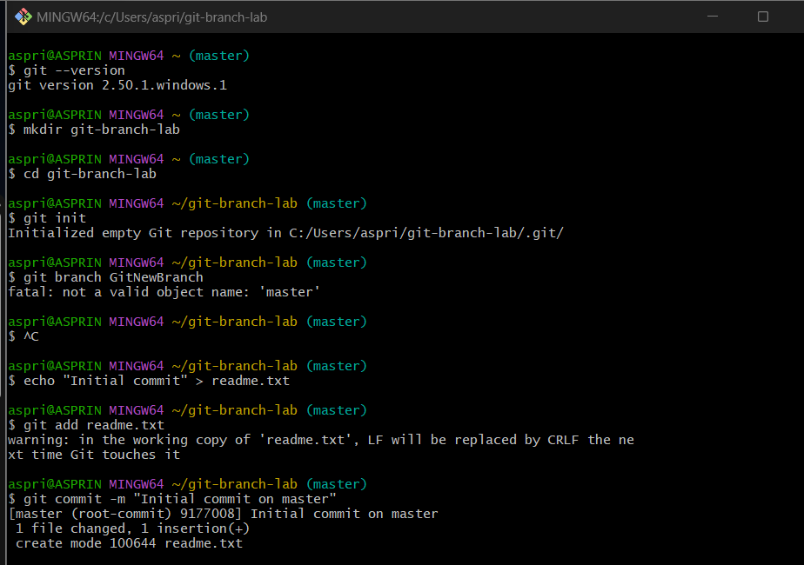

**Step 2: Create a New Branch**

**Description:**  
Created a new branch named GitNewBranch and switched to it.

**Commands Used:**

git branch GitNewBranch

git branch -a

git checkout GitNewBranch

**Screenshot(s):**  
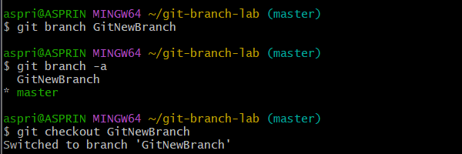

**Step 3: Add Files in the Branch**

**Description:**  
Created a file named branchfile.txt in GitNewBranch, staged it, and committed it.

**Commands Used:**

echo "This is content in GitNewBranch" > branchfile.txt

git add branchfile.txt

git commit -m "Added branchfile.txt in GitNewBranch"

git status

**Screenshot(s):**

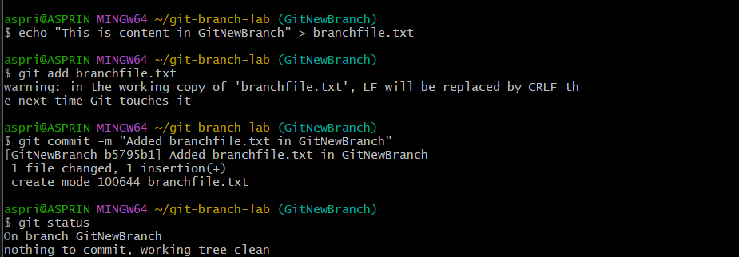

**Step 4: Merge Branch into Master**

**Description:**  
Switched to master branch, compared changes, merged the branch, and viewed the merge history.

**Commands Used:**

git checkout master

git diff master GitNewBranch

git merge GitNewBranch

git log --oneline --graph –decorate

**Screenshot(s):**

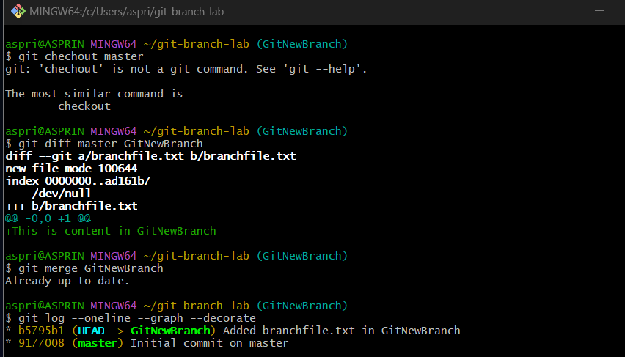

**Step 5: Delete the Branch**

**Description:**  
Deleted GitNewBranch after merging and verified the repository status.

**Commands Used:**

git branch -d GitNewBranch

git status

**Screenshot(s):**

